**Sprint 2 Report**

Sprint duration: March 8, 2021 – April 3, 2021

Number of working days in a sprint: 1 month

Team Members:

Sapan Sharma (6352819), Alanna McNulty (6275168), Alexander Bowles (6089957),

Arooj Fateh (6246185), Alex Orvitz (5517693), Samantha Laffin (5017538), Brian Jenkins (6063481)

## **Sprint Backlog**

|  |  |  |  |
| --- | --- | --- | --- |
| **Item Description** | **Sub-Task Description** | **Team Member(s)** | **Progress** |
| Home Page | Show a list of posts | Alex Orvitz | Complete |
| Interact with posts | Alex Orvitz | Complete |
| Test implemented functionality | Alex Orvitz | In Progress |
|  |  |  |
| Login Functionality | Login UI | Brian Jenkins | Complete |
| Login backend | Sapan Sharma | Complete |
| Login Security | Sapan Sharma | In Progress |
| JUnit Test Implemented | Brian Jenkins | In Progress |
|  |  |  |
| Profile Page | User profile UI | Arooj Fateh | Complete |
| User profile mapping from database | Arooj Fateh | Complete |
| User updating profile information | Arooj Fateh | Complete |
| Other profile options | Arooj Fateh | In Progress |
| Test implemented functionality | Arooj Fateh | In Progress |
|  |  |  |
| Navigation  Component |  | Alex Orvitz | Complete |
|  |  |  |
| Sign Up | Sign up UI | Brian Jenkins | Complete |
| Sign up Backend | Sapan Sharma | Complete |
| Sign up Methods | Brian Jenkins | Complete |
| Sign up Security | Brian Jenkins | Complete |
|  |  |  |
| Location Map Integration | Map UI | Brian Jenkins | Moved to the final sprint |
| Map placement | Brian Jenkins | Moved to the final sprint |
| Location permissions | Sapan Sharma | Moved to the final sprint |
| Test implemented functionality | Sapan Sharma | Moved to the final sprint |
|  |  |  |
| NPO Information Page | NPO UI | Alanna McNulty | In progress |
| NPO profile mapping from database | Alanna McNulty | Complete |
| NPO updating profile information | Alanna McNulty | Complete |
| Other profile options | Alanna McNulty | Complete |
| Test implemented functionality | Alanna McNulty | In Progress |
|  |  |  |
| Firebase Setup and Management | Firebase Console management | Sapan Sharma | Complete |
| Firebase dependency management | Sapan Sharma | Complete |
| Firebase consistency across project | Sapan Sharma | Complete |
| Firebase image storage and retrieval | Sapan Sharma | Complete |
| Test implemented functionality | Sapan Sharma | In Progress |
|  |  |  |
| Past Donation/  Favourites Page | Page UI | Alexander Bowles | Complete |
| Show list of past donations | Alexander Bowles | Complete |
| Show list of favourites page | Alexander Bowles | Complete |
| Map according to logged in user | Alexander Bowles | Complete |
| Test implemented functionality | Alexander Bowles | In Progress |
| ‘Add to favourites’ button added | Alexander Bowles | In Progress |
|  |  |  |
| Create Post Page | Create post UI | Arooj Fateh | Complete |
| Create fields rules to upload post | Arooj Fateh | Complete |
| Update firebase database | Arooj Fateh | Complete |
| Test implemented functionality | Arooj Fateh | In Progress |
|  |  |  |
| Multiple User Permission Settings and Rules | Separating user classes and access | Sapan Sharma | Complete |
| Create admin level access | Sapan Sharma | Complete |
| Create donor level access | Sapan Sharma | Complete |
| Create NPO level access | Sapan Sharma | Complete |
| Create receiver level access | Sapan Sharma | Complete |
| Test implemented functionality | Sapan Sharma | In Progress |
|  |  |  |
| Notifications | Create notifications on triggers | Sam Laffin | In Progress |
| Signup to notifications | Sam Laffin | In Progress |
| Create other methods to send/receive notifications | Sam Laffin | In Progress |
| Test implemented functionality | Sam Laffin | In Progress |

## **Product Backlog**

|  |  |  |  |
| --- | --- | --- | --- |
| **Item ID** | **Item Description** | **Team Member(s)** | **Progress** |
| DON-18 | Home Page | Alex Orvitz | Complete |
| DON-16 | Login Functionality | Brian Jenkins | Complete |
| DON-19 | Profile Page | Arooj Fateh | In Progress |
| DON-29 | Navigation Component | Alex Orvitz | Complete |
| DON-15 | Sign Up | Brian Jenkins | Complete |
| DON-20 | NPO Information Page | Alanna McNulty | In progress |
| DON-23 | Firebase Setup and Management | Sapan Sharma | Complete |
| DON-28 | Past Donation/Favourites Page | Alexander Bowles | Complete |
| DON-25 | Create Post Page | Arooj Fateh | Complete |
| DON-17 | Multiple User Permission Settings and Rules | Sapan Sharma | Complete |
| DON-26 | Notifications | Sam Laffin | In Progress |
| DON-21 | Chat Interface | Brian Jenkins | To-do |
| DON-22 | Search Engine & Filters | Alex Orvitz | In Progress |
| DON-24 | UI improvements and Design | Alanna McNulty, Alexander Bowles | To-do |
| DON-27 | Location map integration | Brian Jenkins, Sapan Sharma | To-do |

## **Monitoring Progress Toward Goals**

|  |  |
| --- | --- |
| Item ID | Progress Description |
| DON-29 | Navigation between current pages are complete (See Current Navigation Diagram), but they are incrementally updated if needed. |
| DON-23 | Firebase firestore database is used for storing and retrieving user data. How the collections and documents in it are structured was revisited to improve the flow of data and to limit repetition.  Firebase storage was used to store user uploaded photos and later fetch those photos where needed.  ‘In progress’ task is to use release and monitor functionality of Firebase to manage distribution, performance insights and testing of the app when published. |
| DON-17 | Separation of user roles along with security rules is completed. The structure of firestore database is updated to reflect and enforce these rules. |
| DON-28 | Changes were made to both the database hierarchy as well as strategies for formatting lists of documents. The existing favourites page was altered to reflect both of these changes for consistency throughout the software.  Functionality for adding documents to favourites subcollections for each account currently in progress. |
| DON-20 | The non-profit profile page gets all the necessary information from the database. All buttons have been implemented, as well as the settings page so that non-profits can update their profile information. The remaining items to finish are the design, and getting the profile picture using the database rather than using the hard-coded default image. |
| DON-26 | Push notifications for a single device have been completed. Integration with the current Firestore database requires further integration testing with user preferences before becoming functional. Test cases have been outlined and will begin in the next sprint. Notifications to multiple users based on preferences require a user notification preference page. The notification page has been designed and will be integrated into the UI in a future sprint. User profiles in the database will need to be updated to reflect user notification preferences in a future sprint. |
| DON-19 | The user profile of the user and npo profiles are redesigned to reflect changes in the implementation of database. Profile user interface is updated according to the logged in user.  Profile page still needs better UI elements which will be added in next release. |
| DON-15 | Sign-up functionality has been completed to the previous specification.  However, new requirements have been identified. The sign-up functionality will now need to include more options for the user to complete such as address, phone number and name. This new requirement will allow users to input all relevant information without having to make changes in their profile immediately after signup. |
| DON-16 | Log-in functionality has been completed to the previous specification.  As a way of ensuring secure transactions between users and the Firestore database, improves security measures have been implemented. Authentication has also undergone rigorous testing with JUnit and with the Firebase Test SDK. |
| DON-21 | The chat interface is currently in the staging phase. Due to the changes made to the user interface, it is no longer accessible from the main menu. However, the Firebase real-time chat API has been successfully implemented. Testing and accessibility changes will be made in the next sprint. |
| DON-27 | Location map integration is currently in the development. Integration with the app including placement, security and testing has been moved to the next phase. The plan to implement this feature with the Google Maps API has not changed. |
| DON-25 | Create post page has been implemented. UI for the page has been finalized. Post updates the database according to user provided information.  Functionality has been added to add additional data if the logged in user is a NPO organization.  However, functionality to get user location and geostamp from google recommendations still needs to be implemented. |
| DON-24 | As key functionalities are now being completed, revisions and improvements to UI design will be a focus for the upcoming final sprint. |

## **Future release plan**

|  |  |  |
| --- | --- | --- |
| **Item ID** | **Item Description** | **Plan** |
| DON-18 | Home Page | Complete |
| DON-16 | Login Functionality | Complete |
| DON-19 | Profile Page | Improve UI elements of profile page and edit profile page. |
| DON-29 | Navigation Component | Improve the flow of the navigation bar using Bottom navigation bar from Material design |
| DON-15 | Sign Up | Get more user information during signup to populate profile page. |
| DON-20 | NPO Information Page | Get the profile picture using the database rather than using the hard-coded default image, and improve the UI. |
| DON-23 | Firebase Setup and Management | Add release and monitoring features such as test lab. |
| DON-28 | Past Donation/Favourites Page | ‘Add to favourites’ functionality to be implemented through rest of app. |
| DON-25 | Create Post Page | Implementation of location recommendations to get accurate location data. |
| DON-17 | Multiple User Permission Settings and Rules | Complete |
| DON-26 | Notifications | Notification preference page to be added with user settings.  User profile class and database to be updated to reflect notification preferences. |
| DON-21 | Chat Interface | Implement chat activity accompanied by a notification icon on the main page to indicate incoming messages. |
| DON-22 | Search Engine & Filters | Search-bar functionality for the homepage and for all other list pages still to be implemented. |
| DON-24 | UI improvements and Design | Each individual page to be reviewed for optimizations to be made in UI, as well as ensuring consistency throughout the entire app (ie. Colour scheme, icon placement, font style and size, etc.) App also to be optimized holistically (ie. Page hierarchy and navigation) |
| DON-27 | Location map integration | Integrate google map api |

Current Navigation Diagram

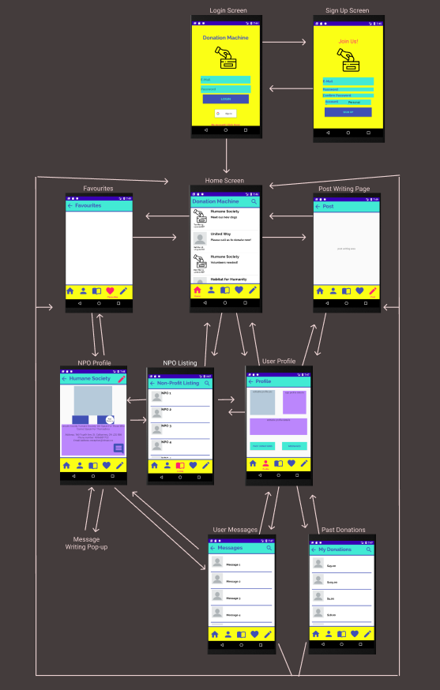

## **Integration Testing**

## Integration Testing with the Firebase Emulator Suite

The integration testing of our application relies the Firebase Emulator Suite. While unit tests are more concerned with functions that the application handles locally such as screen changes and user interactions. The Firebase Emulator Suite focuses on testing functions that interacts with the user authentication system, the instant messaging service or the non-relational Firestore database.

This tool allows us to run our database calls through a test server which can be installed on our local machines. Each local environment is an empty database consisting only of the structure from our cloud production environment. This lets us test repeatedly run the same tests without having to worry about conflicts.

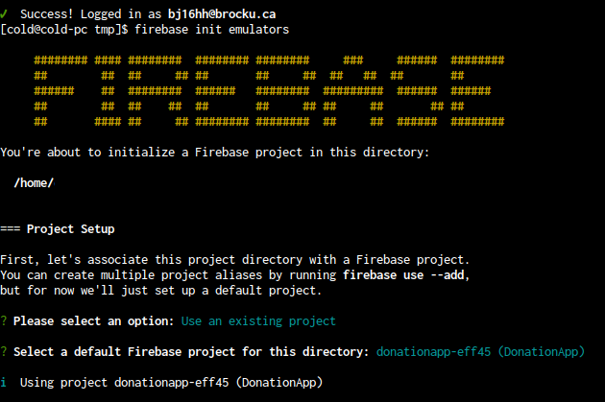

### Sprint 2 Integration Checklist

The integration checklist is a good indicator of which integration tests were completed during this sprint. However, it is important to note that each test case only contains a very high-level description of the work needed to complete each task.

|  |  |  |  |  |
| --- | --- | --- | --- | --- |
| Test Case | Description | Status | Expected Result | Actual Result |
| Sign Up | Allow the user to sign up with their google account or with an email/password combination. | Passed | Firebase authentication entry and firestore entry created for user. | Performed as expected. |
| Log In | Allow the user to log in with Google or username/password combination. | Passed | Successful firebase authentication with application. | Performed as expected. |
| Create/Delete Post | Allow users and NPOs to publish posts on the home page. | Passed | Updates to the post collection in the logged in userid document in Firestore emulator. | Test results reflected the updates performed. |
| Add/Remove Favorite | Allow users to save a list of NPOs or posts for later viewing. | Passed | Fetch post data from a users favourites subcollection. | Post data was retrieved as expected. |
| Retrieve user profile data | Show user data from the database on the profile page of user or NPO organization | Passed | Fetch sample data stored in Firestore database. | Sample data was fetched exactly as expected. |
| Profile picture upload | Allow the user to upload a picture as a display picture. | Passed | Object location of picture uploaded by user during signup. | Object location from where image can be viewed received. |
| Upload a picture for a post | Allow the user to upload a picture related to the post they are posting. | Passed | Object location of picture uploaded by user during post process. | Object location from where image can be viewed received. |
| Update another user profile | User should only be allowed to update their own profile. | Passed | Security rules enforce update rules. | User unable to update any other profile. |
| Search Platform | Allow the user to query the Firestore database for NPO or other user posts. | Failed | Successful complex query performed | Unsuccessful database query. |
| Chat Service | Allow for user-to-user communication via the Firebase in-app messaging platform | Failed | User can send and receive messages. | Communication errors. No message can be received |